1. ls : This command is used for the list and view the files in the current directory.

ls -r command is used for list all the sub directories as well

ls -a command is used for list hidden files

* **ls -al** will list the files and directories with detailed information like the permissions, size, owner, etc.

1. pwd : This command is used to find out the path of the current directory.

1. cd : This command is used for go to straight to home folder in current directory.

* + - cd .. command go to one directory up.

Cd – command go to previous directory.

1. Hostname : This command is used know the name of the network or host.

1. Mkdir : This command is used make or create a new directory.

* + - Mkdir -p command is used to create a parent directory between two existing directories.

1. Rmdir : This command is mainly used to delete only empty directories.

1. Rm : This command mainly used to delete the directories and content within them, and the alternative command is used for rmdir is rm -r

1. Touch : This command is used create a blank new file through the linux command line.

Touch C:\Users\Sai Ram\web.html

To create html file entitled web under the document directory.

1. Locate : This command is used to search or locate a file like search command in windows.

1. grep : This command is used to search all text in given file.

grep blue notepad.txt

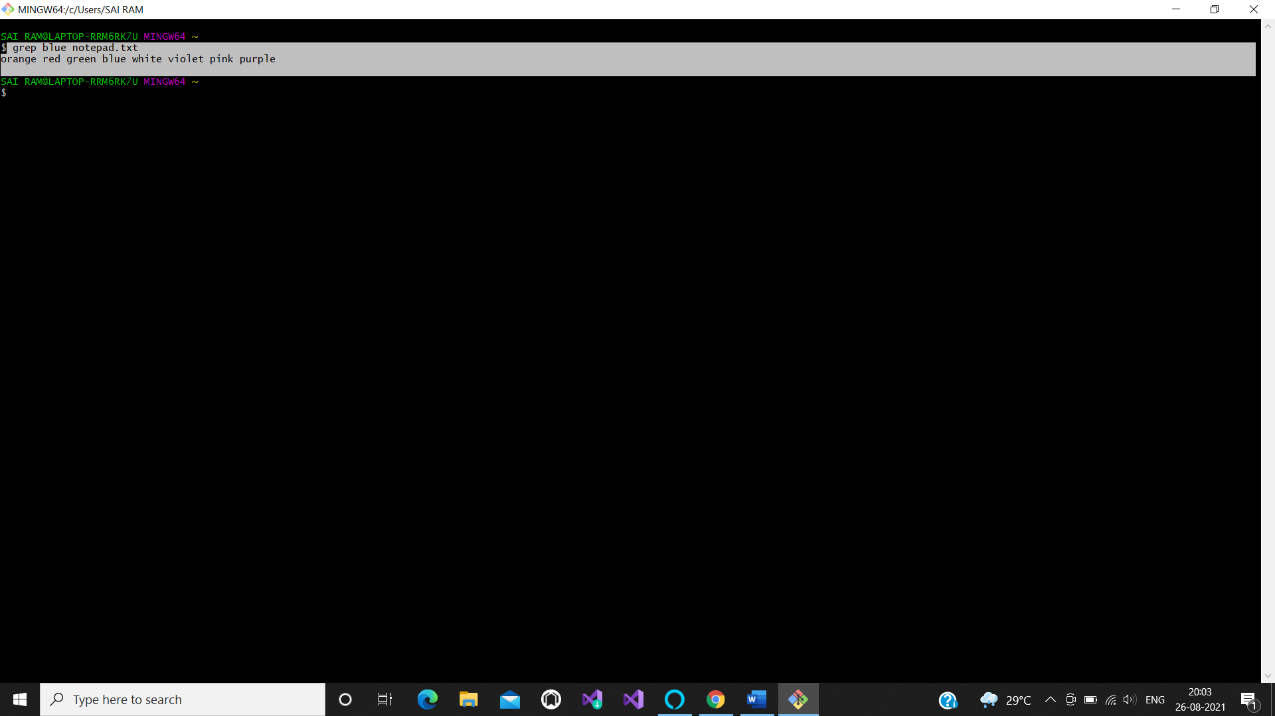

1. df : This command is used to display the system’s disk space in percentage and KBs.

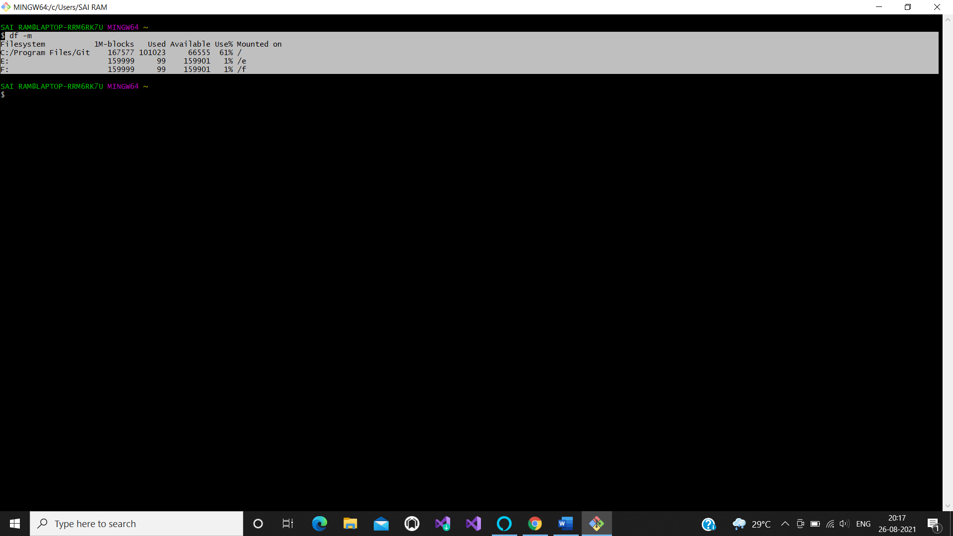

1. du : This command is displaying the disk usage of the file or a directory.
2. Head : This command is used to view the first ten lines of the any text file will display by default.

Ex: head notepad.txt

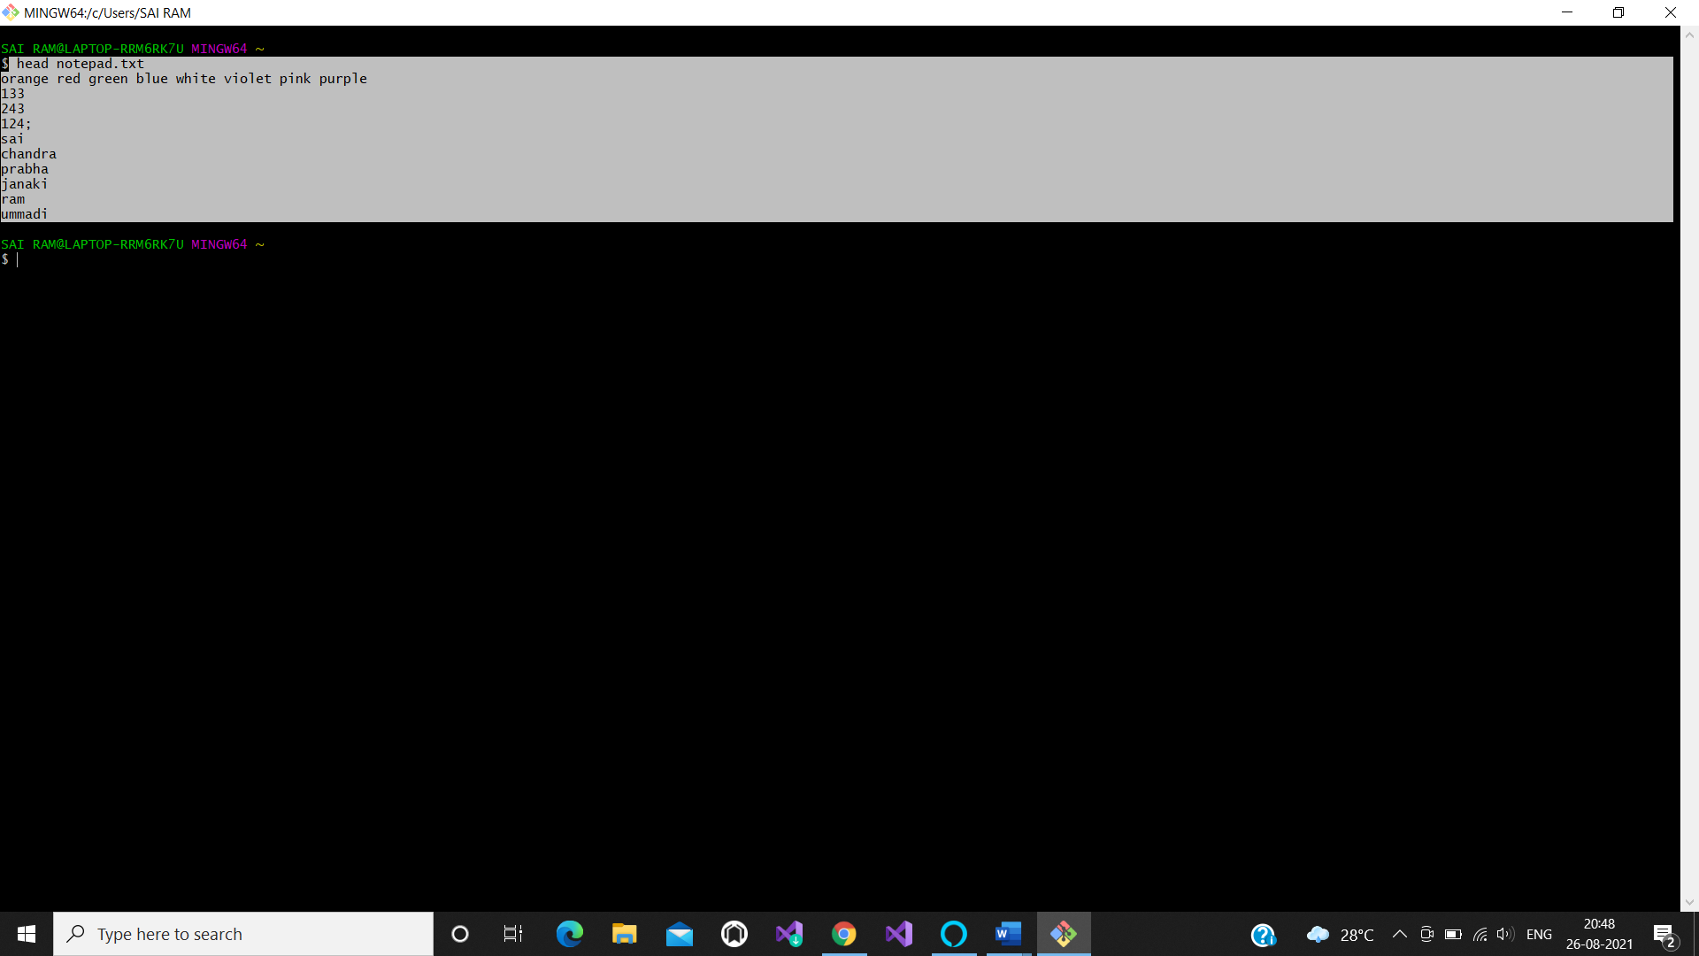

If you want to display the first four lines of a text file it will

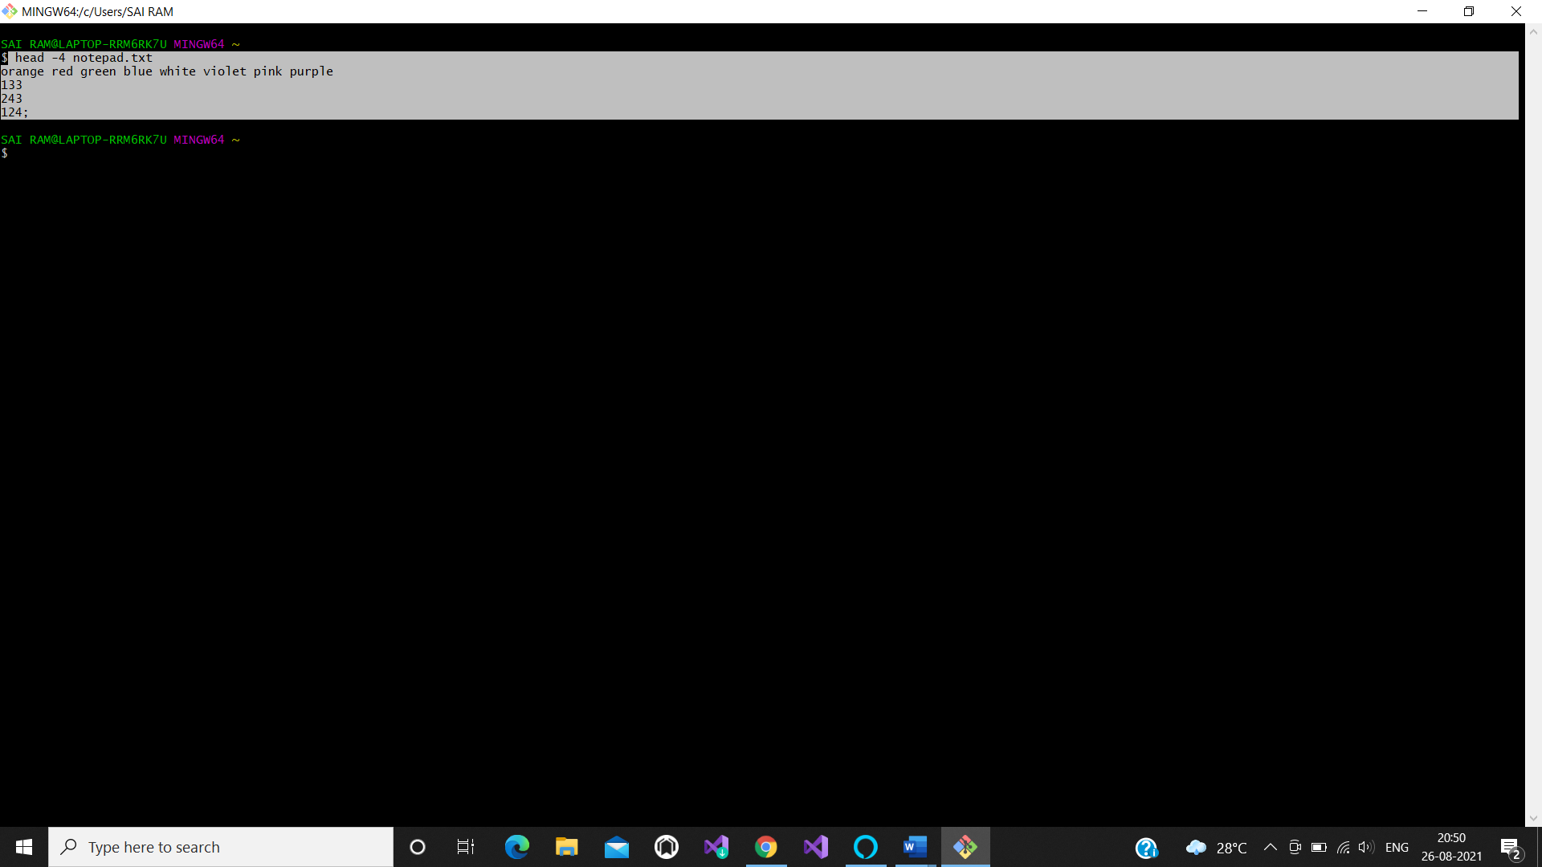

1. Tail : This command is to display the last ten lines of the particular text which you given.

